**FINAL LAB EXPERIMENT**

**Implementing Master/Slave architecture in Jenkins**

1. Start the Jenkins service on command prompt using command:

“java –jar jenkins.war” and go to localhost:8080 on a web browser

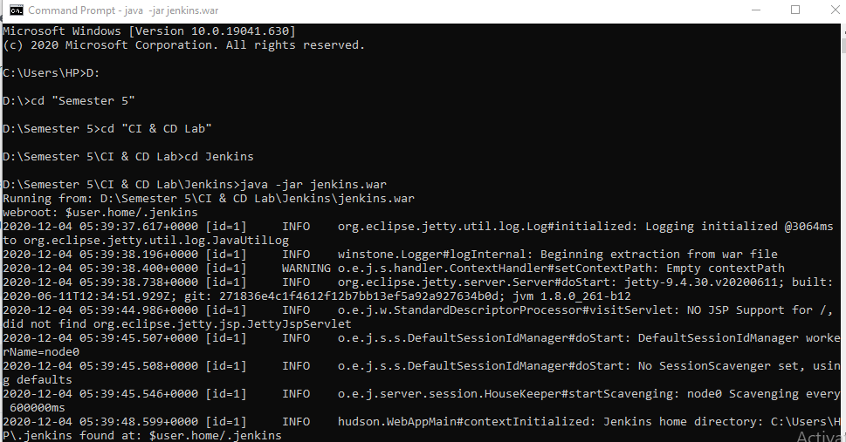

1. Select Manage Jenkins and then Manage Nodes and Cloud

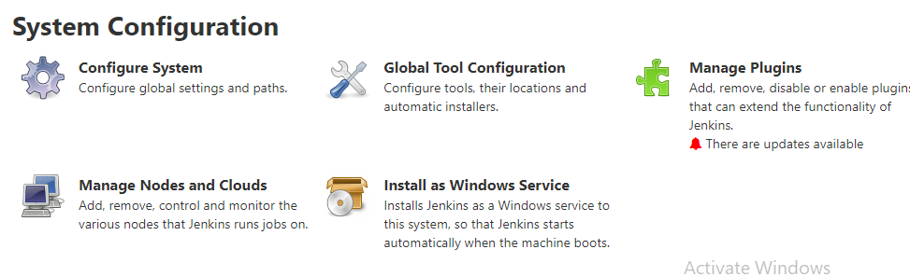

1. Click on “New Node” option. Create a slave node, name and describe it
2. Create a directory for the slave node and provide the location of the directory in the “Custom WorkDir path” and hit save button

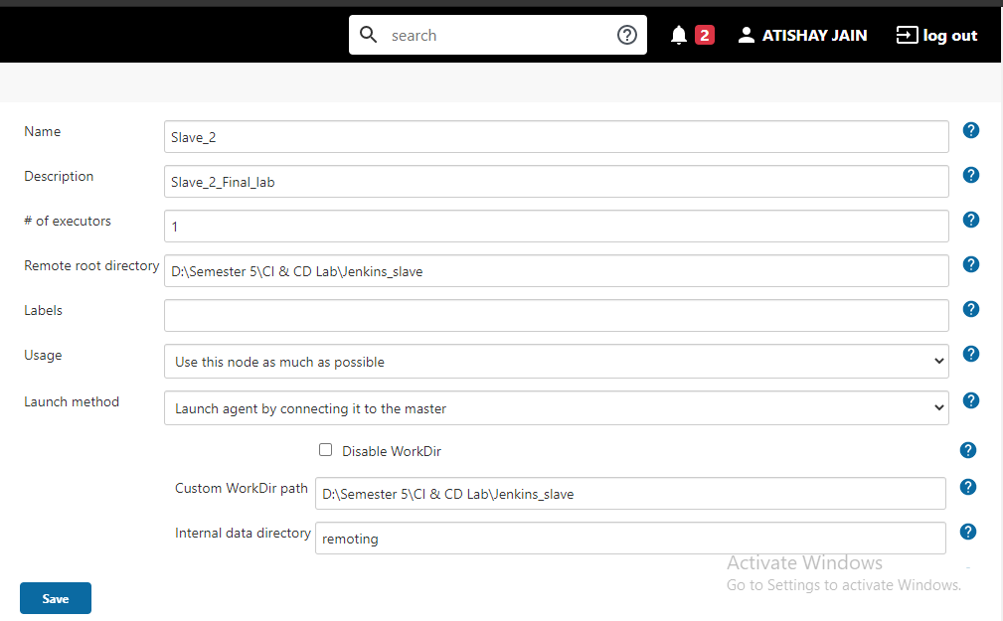

1. Open the folder in your machine for the slave node “Jenkins_slave”
2. A new file “agent.jar” file would have been created. Copy the path of that file
3. Open command prompt and change the directory to the copied location and run the command provided for “Slave_2” in its configuration settings

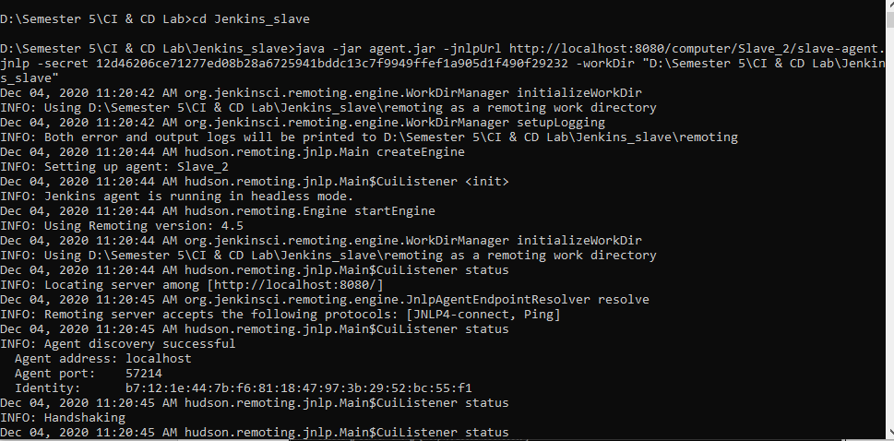

1. Agent “Slave_2” starts to run. Initially it showed inactive with a cross sign accompanying it

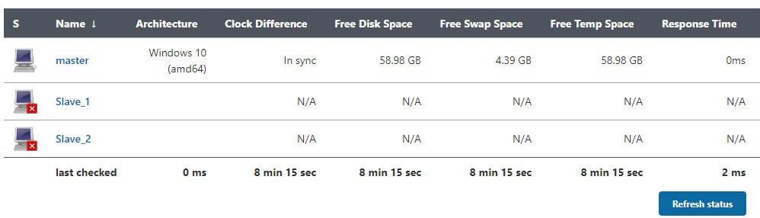

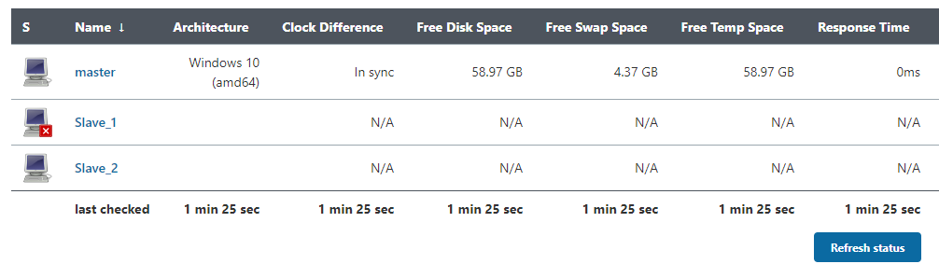

1. Now go to Configurations option of an existing Maven project. In “General” tab, check the option “Restrict where this project can be run”
2. Provide the name of the slave in “Label expression” option and hit save button

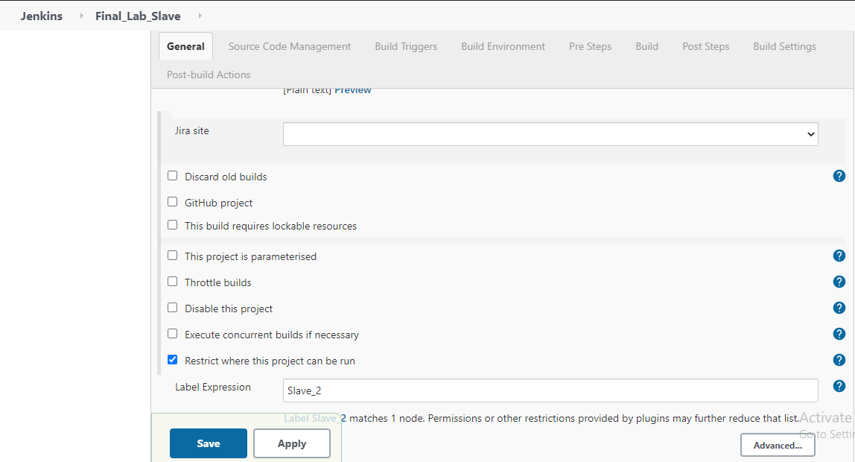

1. Now click on the build now and wait for the process to complete. A build module would be created. Select that module, build artifacts is created there

